


HENDERSON VALLEY MTB – Sat 8th June 2019
www.hendersonvalleymtb.yolasite.com

New Venue Cathcart Country Club

Time Table:
Pre Entry Closing date 5th June No more entries at bike shops
Late Entry Closing date 7th June @ 12:00 (At the venue)!!!!! Or email or fax only
Registration (Saturday) 06:00 to 08:45 NB Race day entries will not be timed

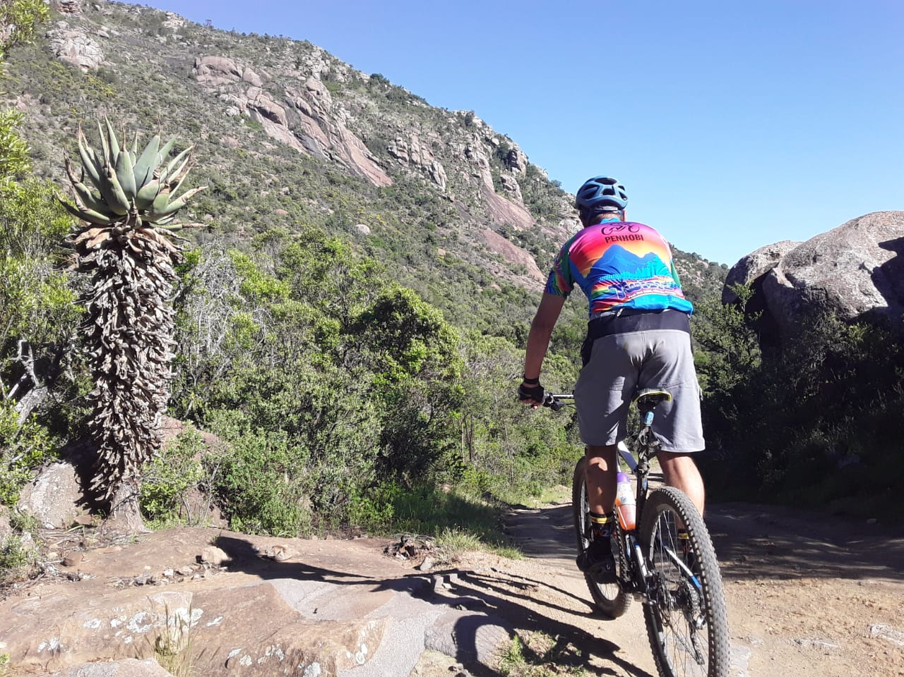
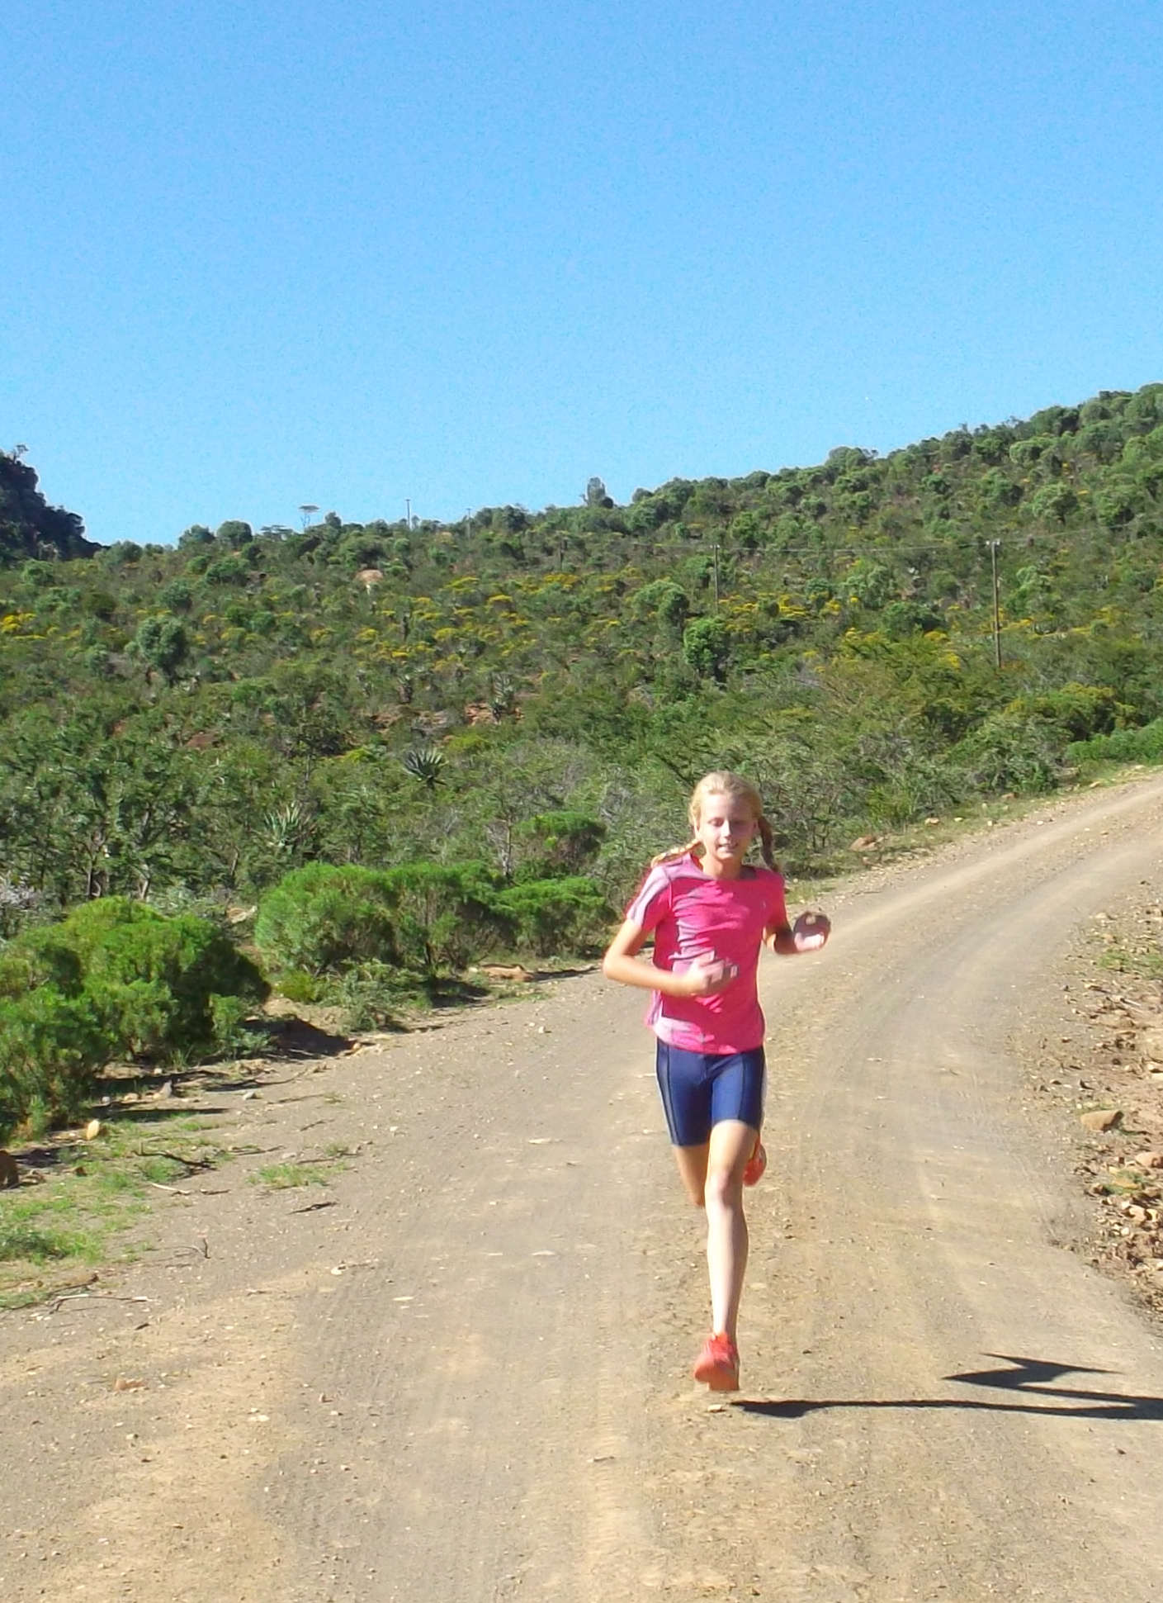
Start Times: 65 km 09:00

30km 09:10

19 km Fun Ride 09:20 20 km Trail Run 09:25

10 km Fun Ride 09:30
10 km Trail Run 09:35
5 km Trail Run 09:40

3km Junior Ride 09:45

Kiddies Fun Ride 09:50 Race Ends 13:30

Prize Giving & lucky draws 14:00
CATERING

Saturday : Breakfast from 07:00

Free Mid day Meal from 12:00

Accommodation Please refer to www.hendersonvalleymtb.yolasite.com

Email Entry forms to hendersonmtb@gmail.com or fax to 086 6114704 (with proof of payment)
Directionsa
From East London: on the N6 Turn right turn right to the Country Club as you leave Cathcart. From Fort Beaufort left into the N6 then right as you leave town. From Queenstown left into the Country Club as you enter town. NB no gravel roads!!!
We are fortunate to get the following sponsors. Please support them!!! More Sponsors being secured daily.
































lease support our sponsors we could not run the race without them

